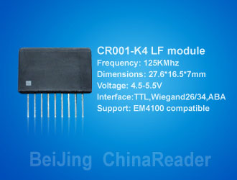
CR001B-K4 SERIES Proximity Reader Module
DATA SHEET(May 8, 2005)
Low Cost Short-Range Proximity Reader Modules
Operational and Physical Characteristics
Parameters | Description | Photo
Read Range | 8-12cm
Dimensions | 26.5mm(L)x16.5mm(H)x6.9mm(W)
Frequency | 125kHz
Card Format | EM 4001 or compatible
Encoding | Manchester 64-bit, modules 64
Power Requirement | 3VDC @ 30mA nominal
Voltage Supply Range | +2.7V through +3.6VDC

Pin Description & Output Data Formats
Pin No. | Description | CR001B-K4-2 (ASCII) | CR001B-K4-W2(Wiegand26)
Pin 1 | To External Antenna | Antenna | Antenna
Pin 2 | To External Antenna(L:680uH) | Antenna | Antenna
Pin 3 | Con | Strap to Vcc(High Volts) | Strap to Vcc(High Volts)
Pin 4 | BEEPER/LED Drive | 2.7kHz Logic | 2.7kHz Logic
Pin 5 | DATA0 | CMOS Data Output(TX) | Zero Output
Pin 6 | DATA1 | TTL Data（inverted）Output | One Output
Pin 7 | CS | CS | HOLD Output
Pin 8 | Zero Volts Or Ground | GND 0V | GND 0V
Pin 9 | DC Voltage Supply(Vcc) | +2.7V through 3.6VDC | +2.7V through 3.6VDC
DATA FORMATS
CR001B-K4-2 Output Data Structure – ASCII(RS232.TTL)9600,N,8,1
STX (02H) | DATA(10 ASCII) | CHECK SUM (2 ASCII) | CR | LF | ETX (03H)
[The 1byte (2 ASCII charaters) Check sum is the “Exclusive OR” of the 5 hex bytes(10 ASCII) Data characters.] For Example:DATA : 62H E3H 08H 6CH EDH, Check Sum: (62H) XOR (E3H) XOR (08H) XOR (6CH) XOR (EDH)=08H, Output: 0X02 0X36 0X32 0X45 0X33 0X30 0X38 0X36 0X43 0X45 0X440X0D 0X0A 0X03
CR001B-K4-W2 Output Data Structure–Wiegand 26 bit
1 | 2 | 3 | 4 | 5 | 6 | 7 | 8 | 9 | 10 | 11 | 12 | 13 | 14 | 15 | 16 | 17 | 18 | 19 | 20 | 21 | 22 | 23 | 24 | 25 | 26
P(1) | E | E | E | E | E | E | E | E | E | E | E | E | O | O | O | O | O | O | O | O | O | O | O | O | P(2)
EVEN Parity(E) |  |  |  |  |  |  |  |  |  |  |  |  | ODD Parity(O)
P(1):Parity Start Bit, 2-13 bit EVEN Parity bit
P(2):Parity Stop Bit, 14-26 bit ODD Parity bit
Wiegand Output Structure
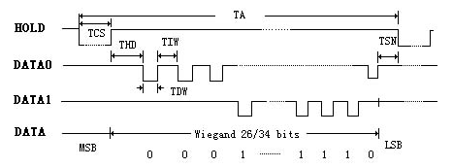
SYMBOL | Parameter | Limits Min. | Limits Max. | Type | UNITS
THD | Hold Start data read delay time | 0.5 | 2 | 0.55 | mS
TDW | Data Pulse width time | 20 | 100 | 50 | μS
TIW | Data Pulse interval time | 0.2 | 4 | 1.1 | mS
TSN | Data Send delay time | 5 | - | 80 | mS
TCS | Hold and Start read time | 40 | 120 | 100 | mS
TA | Total scan time | 100 | - | - | mS

